









DNS Domain name System

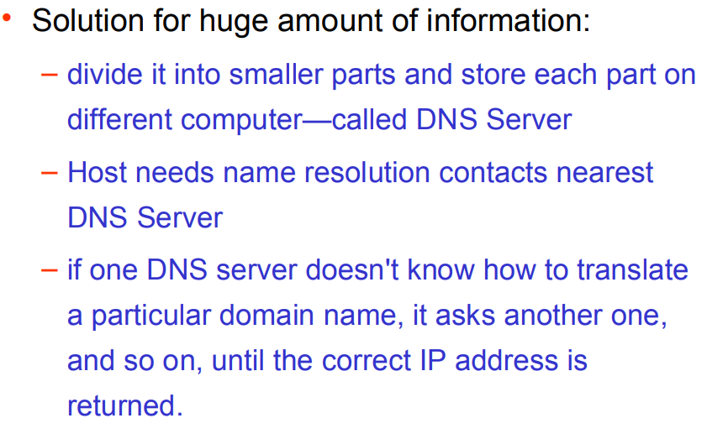

#### TYPES OF NAME SERVERS

Following are the three categories of Name Servers that manages the entire Domain Name System:

1. Root Server
2. Primary Server
3. Secondary Server

ROOT SERVER

Root Server is the top level server which consists of the entire DNS tree. It does not contain the information about domains but delegates the authority to the other server

**PRIMARY SERVERS**

Primary Server stores a file about its zone. It has authority to create, maintain, and update the zone file.

SECONDARY SERVER

Secondary Server transfers complete information about a zone from another server which may be primary or secondary server. The secondary server does not have authority to create or update a zone file.

## DNS Working

DNS translates the domain name into IP address automatically. Following steps will take you through the steps included in domain resolution process:

* When we type **www.tutorialspoint.com** into the browser, it asks the local DNS Server for its IP address.

Here the local DNS is at ISP end.

* When the local DNS does not find the IP address of requested domain name, it forwards the request to the root DNS server and again enquires about IP address of it.
* The root DNS server replies with delegation that **I do not know the IP address of www.tutorialspoint.com but know the IP address of DNS Server.**
* The local DNS server then asks the com DNS Server the same question.
* The **com** DNS Server replies the same that it does not know the IP address of www.tutorialspont.com but knows the address of tutorialspoint.com.
* Then the local DNS asks the tutorialspoint.com DNS server the same question.
* Then tutorialspoint.com DNS server replies with IP address of www.tutorialspoint.com.
* Now, the local DNS sends the IP address of www.tutorialspoint.com to the computer that sends the request.

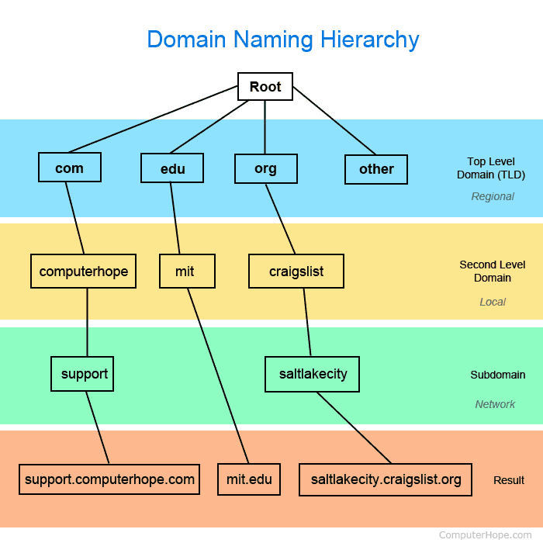

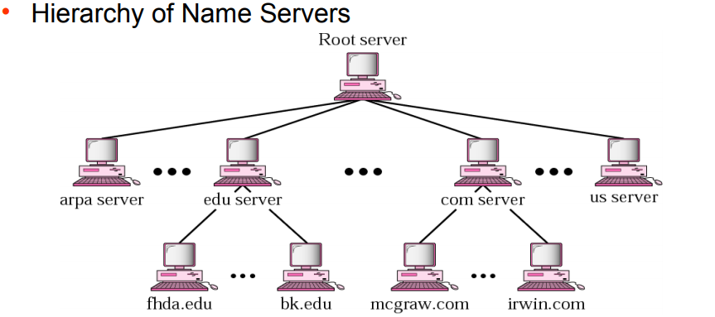

DNS zones, servers –

